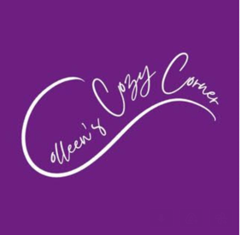

Marketing Internship for Colleen’s Cozy Corner

Colleen Costanzo, a family science alum from UMD, has published two books for children dealing with social and emotional development. She went on to earn a master’s in School Counseling and later received her National Counselor Certification. Colleen primarily worked as an elementary school counselor in MD, NY, and PA. While in NY Colleen also worked as a career counselor for service members getting out of the military. Colleen met her husband while in college and they now live in Pittsburgh with their two children. Colleen's experience as an elementary school counselor and being a mom is what motivates her books.

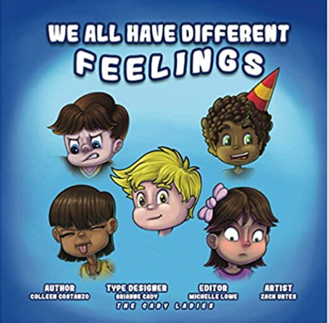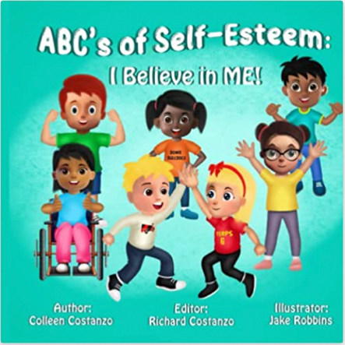

She is looking for a marketing intern to help her with her digital marketing efforts. She has a logo and social media accounts for facebook and Instagram. She would like someone to create content and create ways to increase sales to schools and parents.

This would be a virtual internship. Unpaid. At the most 5 hours a week.

Excellent opportunity to build your portfolio and gain experience in the digital marketing arena.

Please send a cover letter and resume to Colleen at crcady3@gmail.com.

