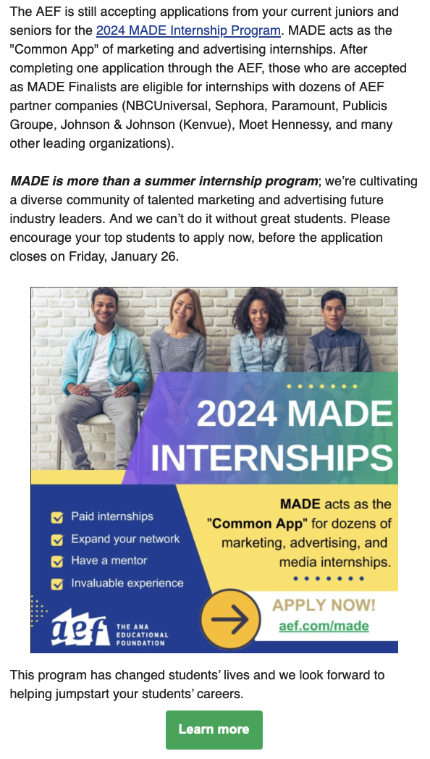

To learn more, go to:
https://aef.com/building-talent/made/made-internship-program/made-students/

