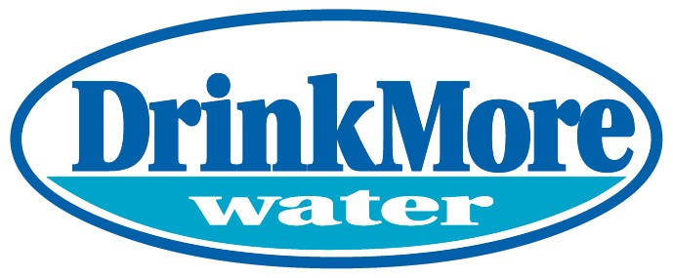
DrinkMore Water is a water purification and bottling company that was founded in 1993. We pride ourselves on providing the purest water available with the best customer service you will find in the industry. Our company has two operating units – DrinkMore Water delivers bulk purified water products within a 50-mile radius of Gaithersburg, MD and DrinkMore Custom Water produces private label water for the Eastern half of the United States. All 45 of our employees are based in Gaithersburg, MD where we purify, bottle, and distribute our products. Depending on what hotels, car dealers, golf courses, or offices you have visited in the past, you may already be a consumer of our product!
Our company has tried various marketing and outreach strategies, but paused our efforts during Covid. This is an opportunity to start fresh. Each business unit serves different customers and requires different strategies – appealing to a DC area resident who is concerned over the quality of their tap water and appealing to a hotel operator in the South East US are naturally different. This is an opportunity to help chart the path forward for a local business.
We are looking for a self-starter who is able to plan, develop, and execute on strategies to grow the business. With no marketing team in place, this will be an entrepreneurial endeavor, working with imperfect data to find the best strategies. This position will be exposed to every facet of growing a business – from google search to Nextdoor advertisements to customer referral sales programs. We will work with the candidate to determine where the highest return is for our dollars.
Our business is locally owned and operated and this position will report directly to the President. The internship will last 8-10 weeks. This is a full time in-office position. Compensation is $20/hour.
Please submit resumes to Mike@drinkmorewater.com.

