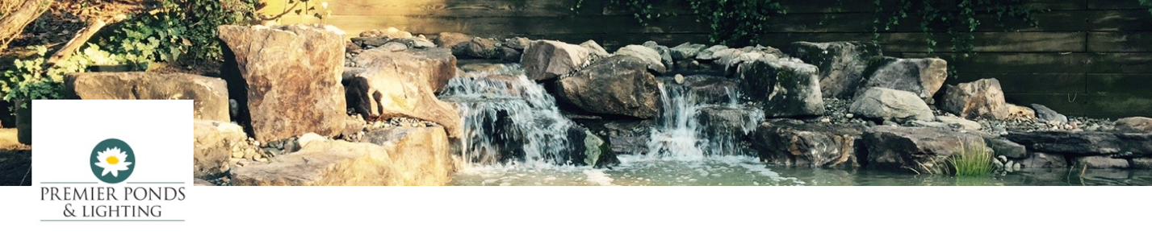

2023 Summer Marketing Intern

Premier Ponds designs, builds & maintains ponds, water gardens, waterfalls & more. Serving Baltimore MD, Washington D.C. & Northern Virginia. Premier Ponds was formed in 2001 but has seen considerable growth in recent years. http://www.premierpond.com

Responsibilities
We're looking for someone interested in marketing/social media/videography. Will be working directly with Smith marketing alum Mark Pankowski every day, shooting, editing, posting, and running paid ads on various marketing platforms. Analyzing advertising results.

Pay: Contingent on experience in marketing, social media and videography.

Contact info:
Mark Pankowski, Vice-president of Marketing for Premier Ponds and Lighting, 301-335-0053, markpankowski4@gmail.com

