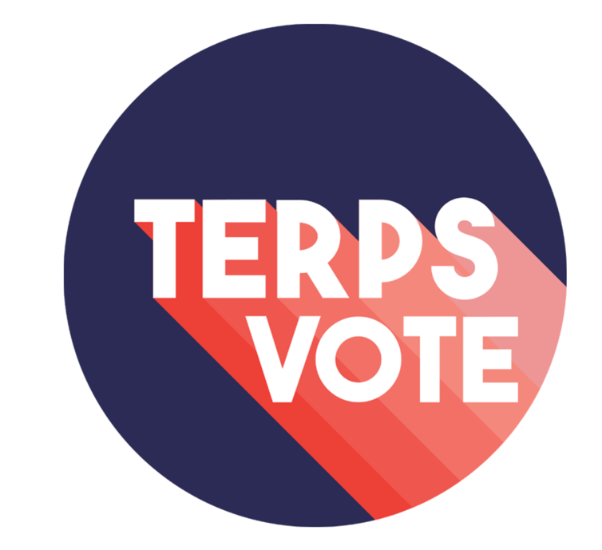

TerpsVote is hiring two paid interns to support our work for the 2022 Midterm election! Interns will help us meet our goals for this fall:
- Increase UMD student participation in 2022 midterm elections through motivation, engagement, and education via campus events and social media.
- Mitigate barriers to student voting through increased information about voter registration, voting procedures, and absentee ballots.
- Maintain a non-partisan approach to voter engagement.
Time Commitment: 10 hours per week from July 1, 2022 through December 10, 2022. Work will be done remotely from July 1 - August 27 and in person during the Fall 2022 semester.
Compensation: $15 per hour, paid via a bi-weekly paycheck.

Qualifications: Qualified candidates will demonstrate an interest in and basic knowledge of voting in the US, as well as demonstrate experience and skills in social media, event planning, research, and/or education outreach. Interns MUST be enrolled at UMD College Park for the Fall 2022 semester (May or August 2022 graduates are not eligible).

For a more detailed position description and the intern application, go to: go.umd.edu/tvintern22. To learn more about the initiative, go to https://terpsvote.umd.edu/. The application is due Sunday, April 3!

