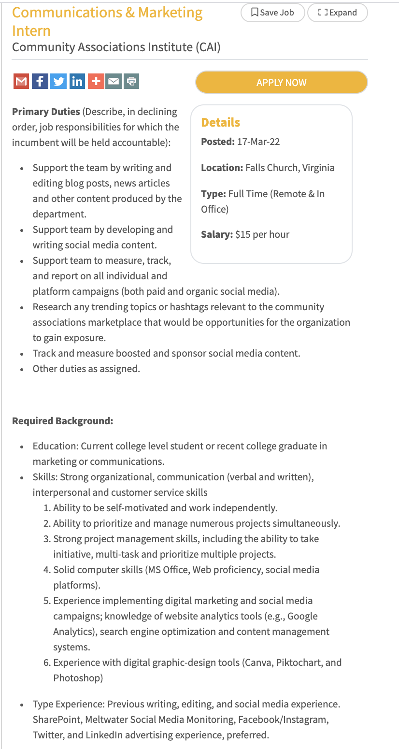
To apply, go to: https://jobs.capitolcommunicator.com/jobs/16483128/communications-marketing-intern

