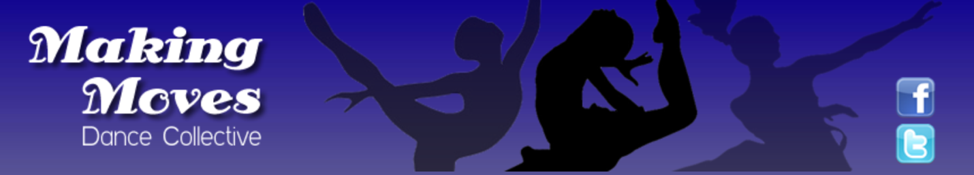

Making Moves Dance Collective (MMDC) is a non-profit dance studio currently in its 17th season. Our mission is to provide a safe and positive arts environment to at-risk and underserved individuals in the Washington, D.C. Metropolitan area. We are located at 5640 Sunnyside Avenue, Beltsville, MD.

We are currently seeking an intern to help strengthen our social media presence and to help market our program in the community. Our ideal candidate should be pursuing a bachelor’s degree in either the marketing or communications field. We are looking for an intern with a working knowledge of Twitter, Facebook, Instagram, LinkedIn, TikTok and any other emerging social media platforms. Additionally, the candidate should have skills with photo and video editing, a creative mindset and the ability to multitask. Experience with Canva is a plus and experience with Adobe Creative Suite is preferred, but not required.

We are currently seeking an intern who would be willing to work for credit hours, experience and exposure. The position does have the potential to develop into a paid contractual position.

The candidate should be available up to 15 hours per week at $15/hour.

Interested candidates should email their resume to makingmovesdc@gmail.com.

